Andrea Khoury

Connecting ssh and Running MySQL

ssh is a protocol to communicate to a server machine. Putty is a software for pc’s to connect to a server via ssh. For this project I have downloaded putty on my computer. When starting to comput, this will pop up:

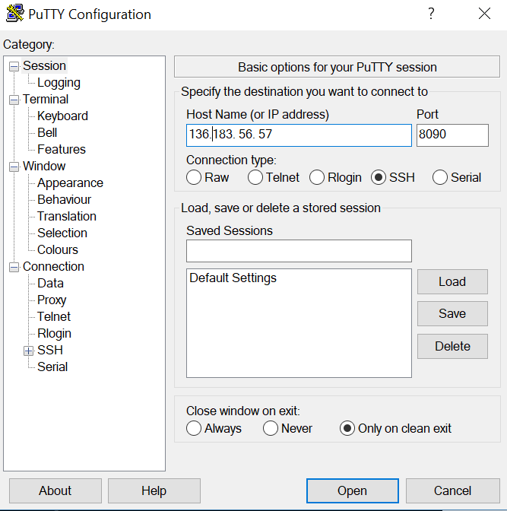

1. You have to type in the IP address
2. Then port 8090, which is the schools computers instead of the defult of 22 that will already be placed in the box. The reason for this is for security reasons.

After entering the information above, the ternimal will then open and you enter in your login to the computer and the password.

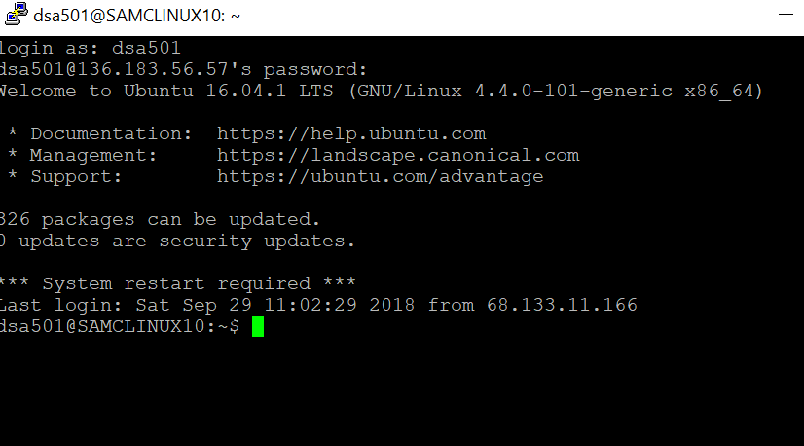

Next, enter in the ssh protocol and the computer in which you would like to search then type in the IP address. From there you can then search any file in computer.

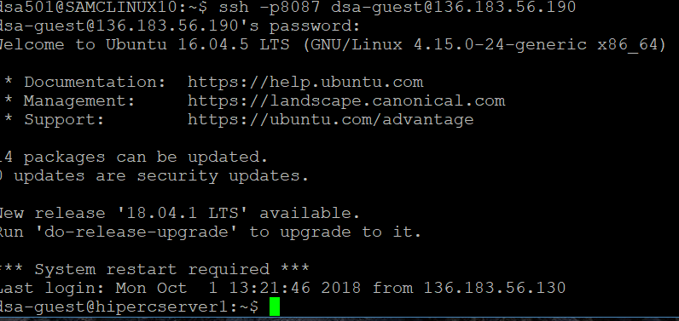

After that, enter in the mysql server and the username then password of the user and once you have data access for that you can look at the files you have created within that file.

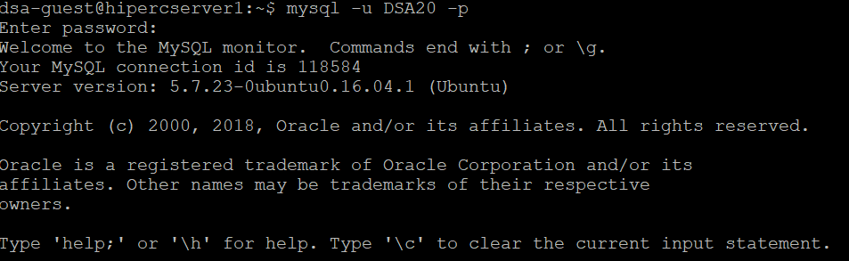

Next, In mysql I wanted to see the different databases that are on MySQL and for that you would write, show databases; and the table below is what will appear.

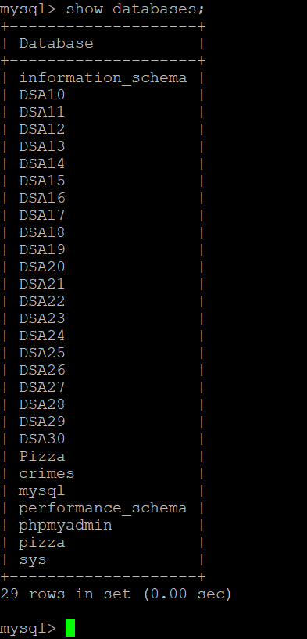

After looking into the database, I have selected my username DSA20 by typing in, use DSA20, and from that file I wanted the system to select name from Person which is exactly how I typed it into the server. The reason for this was just to give an example of what type of data you can find and search.

